Beacon Hill Academy



**Administrative Officers**

Dr. Patty Main, Superintendent

Barbara Markland, Treasurer

**Board of Education**

Mark Hochstetler, President

Dennis Keim, Vice-President

Joe Miller

John Henry Miller

Paul Raber

Annual Report

2019-2020

BH

**Dear Friends,**

Beacon Hill Academy celebrates another year of continuous educational service to the Wayne County, Holmes County, and Stark County communities. Beacon Hill Academy offers educational opportunities to include valuable character education and standards-based achievement. Students attending the Beacon Hill educational programming attain treasured friendships, academic and personal growth, and skills that prepare them for a lifetime of success.

An education at Beacon Hill consists of project-based, hands-on academics, blended learning opportunities, and career-preparation. Various partnerships are formed between our communities, families, staff and alumni to ensure current and future success for our students. We are honored to be an integral part of our local communities and thankful for the many partnerships developed throughout the years.

Our promise is to provide students with a well-rounded education, continuous growth, and preparation for life-long success. We promise to provide families with educational opportunities for students to grow academically, socially, and emotionally. We promise to provide our communities and partners with citizens prepared to contribute to the community and the workforce.

Together, we partner to strengthen our communities

Dr. Patty A. Main, Ed.D., pHCLE,

# Beacon Hill Academy Annual Report

## I. Governance

### Board Members

The Beacon Hill Academy Governance Board was comprised of five (5) Board members who represented families, local businesses, and community members in the area. The Governance Board reviewed policies and procedures and monitored school finances and annual goals for student achievement and progress monthly. During each monthly board meeting the treasurer provided financial reports to the board for review and approval. The superintendent presented legislative and educational updates to the governance board for review and approval. The Governance Board received curriculum and academic improvement updates.

The Board, along with various stakeholders, continued to monitor progression towards the vision and goals for Beacon Hill Academy. Preparing students for careers, facilities, safety and wellness of students, transportation and food service continued to be addressed.

The Beacon Hill Governance Board for the 2019-2020 school year included the following members:

|  |  |
| --- | --- |
| Mark Hochstetler | President |
| Dennis Keim | Vice President |
| Joe Miller | Member |
| John Henry Miller | Member |
| Paul Raber | Member |

### Mission

*Beacon Hill Academy provides a guiding light for our community’s career and educational needs. We work closely with our families and the community to offer unique, personalized educational opportunities for all students. Our innovative and engaging educational programs utilize a blend of traditional classroom experiences, new-age eLearning platforms and integrated career-oriented experiences that optimize our student success.*

### Overview

Beacon Hill Academy operated as a site-based, conversion community school sponsored by the Ohio Department of Education, Department of Community Schools. Beacon Hill Academy operated at 10470 Winesburg Road, Dundee, Ohio 44659 in Wayne County. The 2019-2020 school year was the Seventh full year of operation for Beacon Hill Academy. The Superintendent was Dr. Patty A. Main and the Treasurer was Ms. Barbara Markland. Educational programing and services were available for students in grades 7- 12. The operation of the educational program focused on student populations at-risk of attaining a high school diploma in the traditional school setting as well as students whose cultural beliefs limit traditional participation beyond a certain grade level.

Due to COVID-19 and Ohio Department of Education changes in state-wide testing, Beacon Hill did not participate in annual state assessments. However, the District Report Card released in Fall 2019 reflect the following academic data.

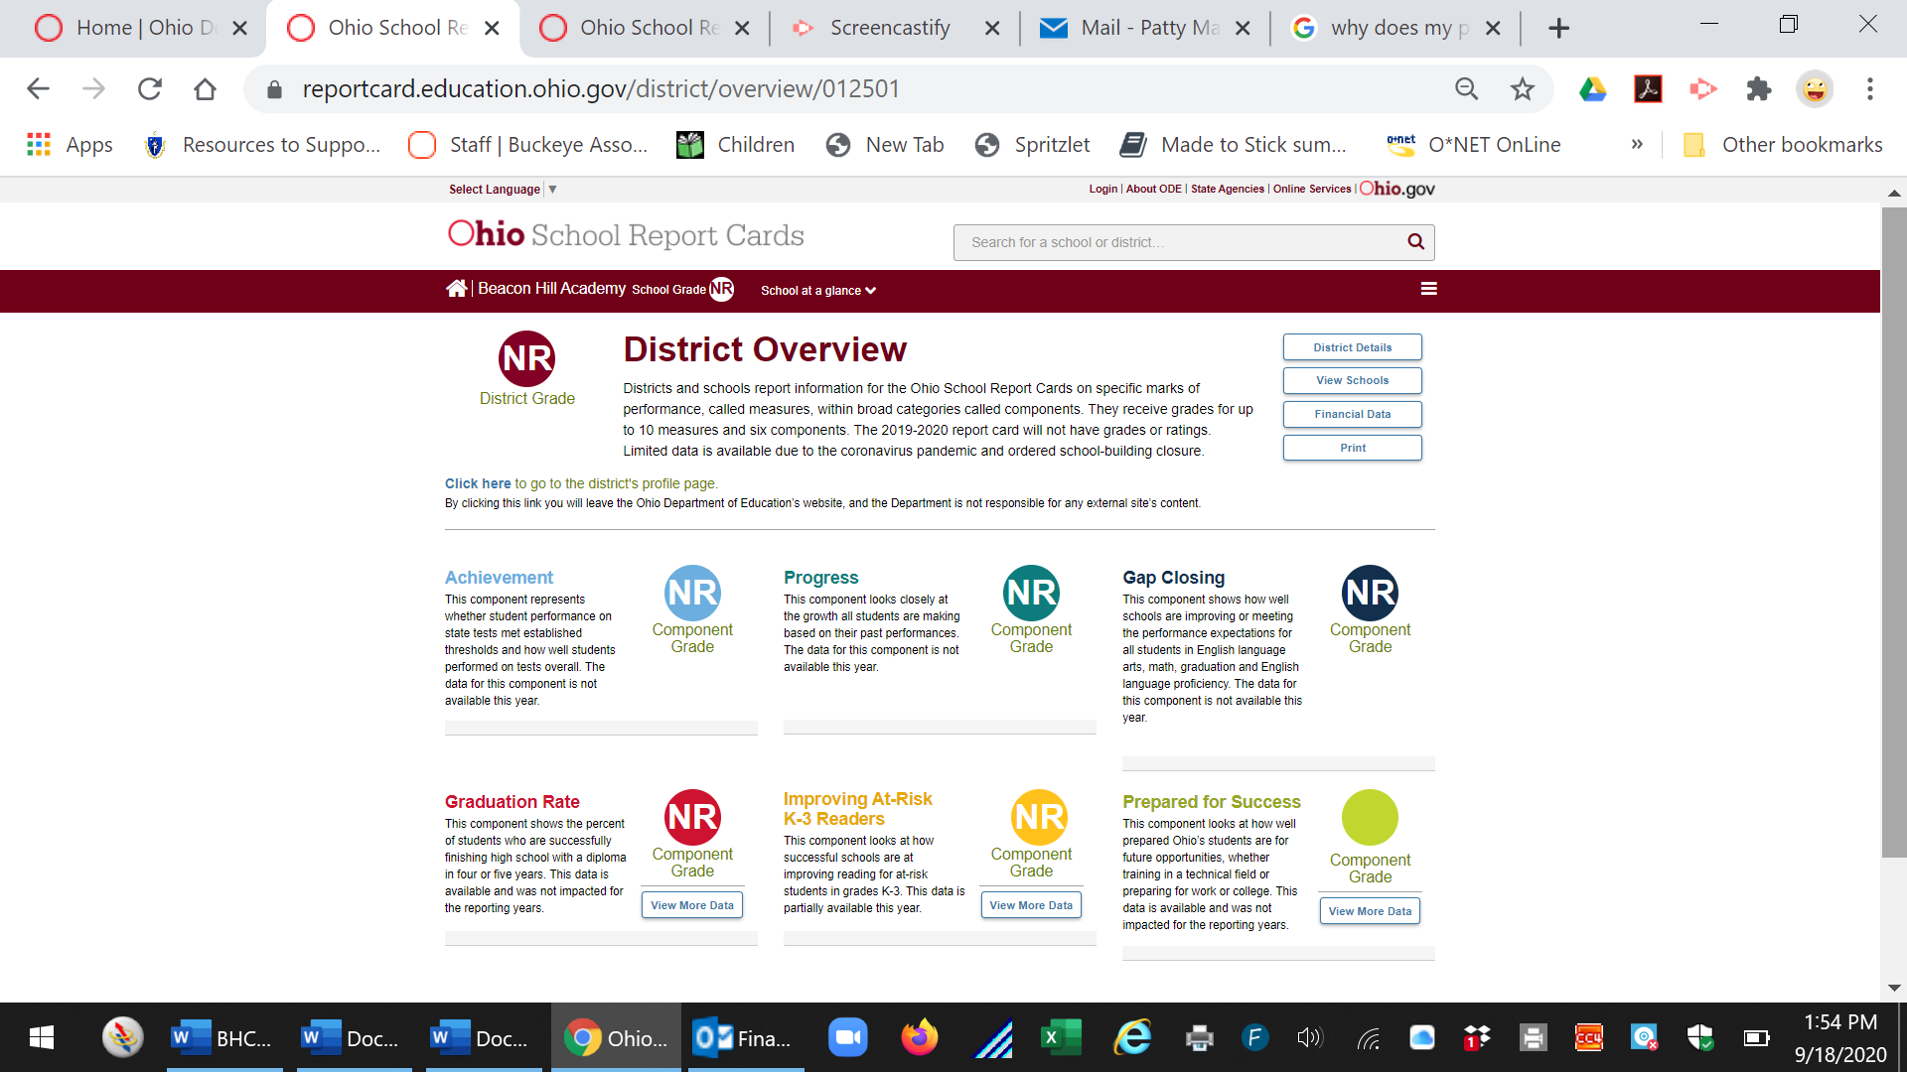

## II. Operations

### Staffing

The staff for the 2019-2020 school year at Beacon Hill included a part-time administrative team of one (1) Superintendent, one (1) Treasurer and one (1) Building Administrator. There were five (5) instructional staff member which included one (1) full-time teacher and (4) part-time teachers. Support staff included one (1) full-time classified staff member, one (1) part-time guidance counselor and multiple shared-service contracts for personnel such as a nurse, EMIS coordinator, Technology Service personnel, speech therapist, and school psychologist.

The instructional staff at Beacon Hill provided traditional classroom instruction, vocational education, supplemental eLearning curriculum, blended learning, career readiness preparation, and community service experiences for students grade 7-12. Each staff member was certified in their respective subject areas and held a bachelor’s degree in the subject area. Staff completed professional development aligned to learning goals through course work, training, workshops and/or professional learning communities.

### Enrollment

Beacon Hill was established as a Conversion Community School whose purpose was to provide formal education for an underserved population in one school district within Wayne County. The elimination of specially designed middle school units resulted in a need for additional educational opportunities for middle school aged students in the immediate area. Over the years, the educational programming expanded to include additional grade levels (9-12) and served five school districts within three surrounding counties during the 2019-2020 school year.

At the opening of the 2019-2020 school year, sixty-five (65) students were enrolled. During the school year one (1) additional student enrolled in the program. Throughout the year, two (2) students withdrew; one (1) student transferred to another school and one (1) student transferred to homeschooling. The final enrollment on the last day of the school year was sixty-four (64) students. Zero (0) students graduated with a high school diploma at the end of the 2019-2020 school year.

##### Student Enrollment by Grade Level

|  |  |
| --- | --- |
| **Grade** | **Total** |
| Grade 7 | 30 |
| Grade 8 | 27 |
| Grade 9 | 3 |
| Grade 10 | 2 |
| Grade 11 | 3 |
| Grade 12 | 0 |
| **TOTAL** | **65** |

### 

##### Student Attendance Rate

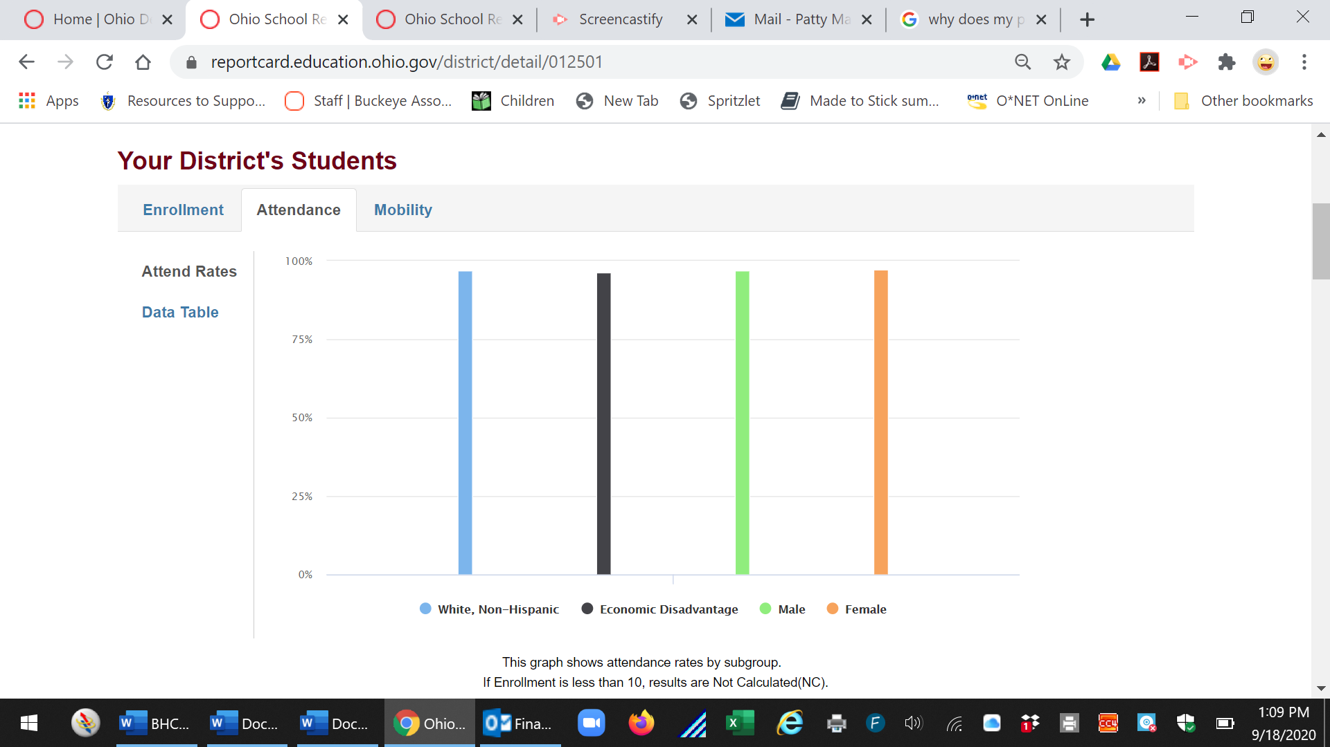

### Demographics

The student population served by Beacon Hill Academy was from the surrounding Amish and Mennonite communities within the Wayne, Holmes and Stark counties. Formal education for students from our communities generally concludes at the end of grade six at which time they withdraw to Home School or at the end of eighth grade invoking Yoder vs. Wisconsin to leave school entirely.

##### Student Enrollment Demographics

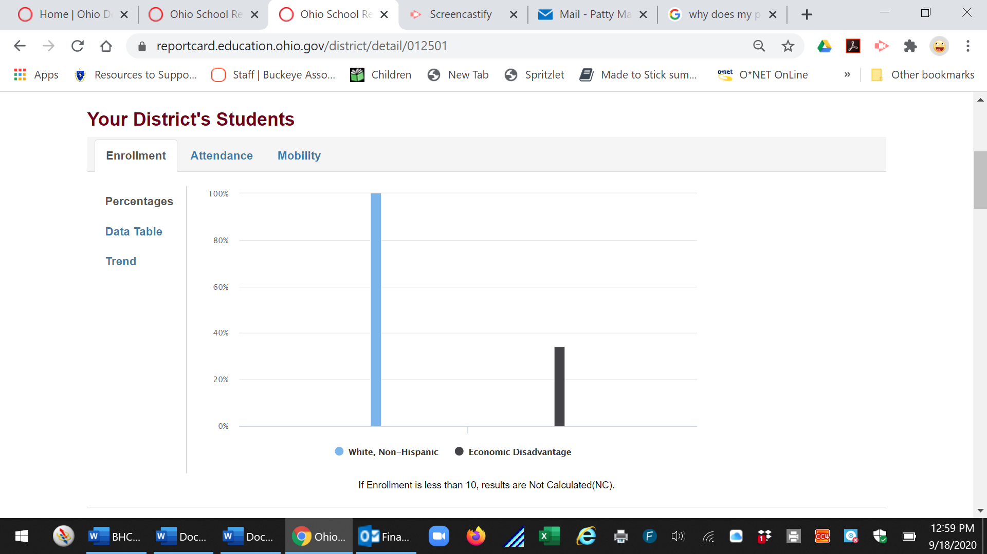

### Student-Teacher Ratios

The ratio of students to teachers for the 2019-2020 school year was approximately 14:1. Student core subject classes consisted of approximately 28 students per class. Building Trades, Home Economics, and German classes consisted of approximately 14 students per class. Other learning opportunities consisted of individualized and small group (3-5 students) instruction.

### Community Partners

Beacon Hill Academy partners with Plain community businesses and agencies in our attendance area for community service, field trips, job shadowing, and guest speakers and panels to promote employment opportunities for our students. These opportunities included baking macarons with Jenn Bakes of Canton and arranging flower bouquets with Karen’s Garden of Kidron with which to bless people within the community. More than twenty students, along with some staff, parents and siblings ran together in the Rich Dalessandro 5k Benefit race in the fall.

Through an art grant sponsored by the Wayne County Community Foundation, Beacon Hill hosted a variety of local artisans, such as Terry Shue of Muddy Fingers Pottery and Megan Weaver of Letters & Littles, who taught students about their craft and led them on hands on experiences. Dozens of businesses across the area hosted Beacon Hill students for a variety of job-shadowing experiences. Career-readiness activities were not only incorporated through field trips in collaboration with Homestead Furniture and Wayne-Dalton Garage Door, but also through Career Day activities in which a large number of community business leaders from across multiple counties joined the school for a question-answer panel, roving booths, and mock-interviews with 8th graders. Students provided service to the community through activities such as roadside cleanup, yard-care, help at local festivals and benefits, among others. Continuous collaboration with family owned small businesses were vital partnerships offering wonderful opportunities and post-graduate employment to the students.

Beacon Hill Academy contracts services for special education and student testing through the Tri-County ESC, food services through Southeast Local Schools (Wayne County), and technology services through the Tri-County Computer Services Association. Community partners include: Lighthouse of Hope, Spring Haven Counseling Center, Mount Eaton Business Association, and Wayne County Workforce Innovation Network (WIN). Beacon Hill also collaborates closely with the Paint Township Fire and EMS, Wayne County Sheriff’s Department, and the Wayne County Emergency Management Agency to ensure readiness for student safety in potential emergency situations.

## III. Academics

### Academic Results

Student performance resulted released in fall 2019 reflect an overall “B” grade for Beacon Hill Academy. Six components were used by the Ohio Department of Education to evaluate the district performance. Beacon Hill received an “A” in two (2) areas which were student progress and gap closing; “B” in one (1) area which was student achievement; and “F” in one (1) area which was graduation rate. Student achievement resulted in meeting all indicators.

Student assessment data for the 2019-2020 school year is not available due to the COVID-19 pandemic.

##### Six Components of the Report Card

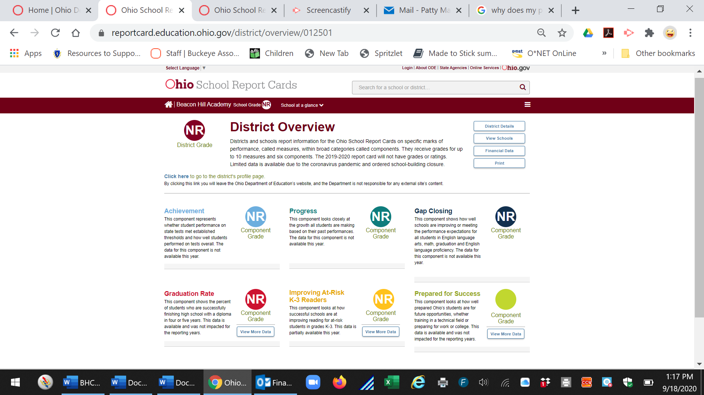

##### Student Performance: Indicators Met

Not Available for the 2019-2020 school year due to COVID-19 building closure and assessment waiver.

##### Student Progress: Growth

Not Available for the 2019-2020 school year due to COVID-19 building closure and assessment waiver.

### Curriculum Model

Site-based and remote learning were the basis of instruction for students enrolled in Beacon Hill Academy programming during the 2019-2020 school year. Learning opportunities were aligned with the Ohio Learning Standards and community needs. Instruction in core areas and vocational education, such as Home Economics and Building Trades were provided for students as well as instructor guided e-Learning modules and courses in various core and supplemental subject areas through Edgenuity. Career and service-learning opportunities were also included in the educational programing during the 2019-2020 school year. This curriculum is used to provided students individualized pathways for high-school graduation, life-long career/educational pursuits, and employment opportunities.

### Assessments

Multiple points of data were used for tracking growth and performance for Beacon Hill Students to include diagnostic, benchmark assessments, and project-based performance. Students received the benefit of i-Ready as a diagnostic and supplemental instructional program. Student progress and growth were monitored using assessment performance. Multiple points of data were reviewed for each student and areas of strength and concern were identified for students on an individual level. Staff used an array of available assessments and student results to adjust classroom instruction.

Complete assessment data for the 2019-2020 school year is not available due to the COVID-19 pandemic.

### Academic Goals & Data

Data was reviewed and analyzed to determine the root cause for areas of concern aligned to the school mission and goals. Three goals for the 2019-2020 school year and the school mission statement were used to determine progress and to identify program adjustments. Progress on each goal was monitored during the year.

Goal 1: Spring AIR tests were not administered due to the COVID-19 and closure of the building. Therefore, no data is available to measure progress for Goal 1. The 2020 graduation cohort contained less than 10 students. Therefore, no data is available for goal 2.

|  |  |  |
| --- | --- | --- |
| **Goal 1** | Increase passage rate in 8th Grade English Language Arts from 69% to 85% or more by the Spring AIR tests in 2020. | N/A |
| **Goal 2** | Increase the number of students entering 9th grade to the number of students in the cohort at graduation from 40% to 80% by 2021. | No progress |
| **Goal 3** | Increase student enrollment to Beacon Hill Academy from 58 to 70 by Fall 2021. | Progressing |

#### Goal 1: Student Achievement and Progress

During the 2019-2020 school year, the English Language Arts AIR tests were not administered due to the COVID-19 and the school building closure. Student and building data is not available to measure progress.

#### Goal 2:

The 2020 graduate cohort included less than 10 students. Therefore, no graduation data is available to publish. However, the number of students entering high school, 9th Grade, increased from 3 students in 2018-2019 to 5 students in 2019-2020. Thus, resulting in an additional student enrollment in the high school program for the second year. Student re-enrollment in the high school program increased from 50% to 100% during the 2019-2020 school year.

##### Student Enrollment by Graduation Cohort

|  |  |  |  |
| --- | --- | --- | --- |
| **Cohort** | **Grade 9** | **Grade 10** | **Retention** |
| Class of 2021 | 2 | 1 | 50% |
| Class of 2022 | 3 | 3* | 100% |
| Class of 2023 | 3 | 3 | 100% |
|  | | | |

#### Goal 3:

During the 2019-2020 school year, enrollment increased for the Beacon Hill Academy. There was an increase in enrollment from 56 students to 65 students. Enrollment increased by 13.8% within one year. Beacon Hill Academy continued to adjust programming to address local educational needs and expectations of our families and students.

##### Fall Student Enrollment by School Year

|  |  |  |  |
| --- | --- | --- | --- |
| **Grade** | **2017-2018** | **2018-2019** | **2019-2020** |
| Grade 7 | 24 | 25 | 30 |
| Grade 8 | 27 | 27 | 27 |
| Grade 9 | 3 | 2 | 3 |
| Grade 10 | 6 | 1 | 2 |
| Grade 11 | 1 | 0 | 3 |
| Grade 12 | 3 | 1 | 0 |
| **Total** | 64 | 56 | 65 |

### Career Credentials

Beacon Hill students learned valuable skills through participation in middle school vocational education programs, job shadowing, and field trips to explore career fields.

### Graduates

Over ninety percent (90%) of our students are from local Amish and Mennonite communities.  The families within our communities generally see merit in formal education through grade eight, at which time they invoke Yoder vs. Wisconsin and leave school entirely. Historically, few students, continue formal education at the high school level upon completion of grade 8.  Furthermore, many of the students attending high school enter the workforce at age sixteen or earn a GED rather than pursing a high school diploma. Exiting formal education upon completion of Grade 8 is considered the norm within the community, local businesses, and culture. Any formal education after eighth grade should be viewed positively rather than negatively.

##### High School Graduation Rate

The 2019-2020 Graduation cohort was less than 10 students. Therefore, no data is available for publication.

### Scholarships and College

Beacon Hill Academy prepared students during the 2019-2020 school year for success in future endeavors in citizenship and college and career readiness. Opportunities are available for students to explore and prepare for both a career and college option. The 2018-2019 Graduating cohort was less than 10 students. Therefore, no data is available for publication.

## IV: Financial

### Financial Data

The Beacon Hill Academy treasurer was properly licensed and bonded and completed fiscal reporting for FY19 in an accurate manner. The treasurer provided written monthly financial reports to the Governing Authority and the Sponsor of the School. The reports were reviewed and approved by the Governance Board monthly. Expenditures for 2019-2020 was $8.060 for Beacon Hill compared to the state average per pupil expenditure of $9,883. Decreased from $9179 in 2018-2019 to $8,060 in 2019-2020.

##### Spending Per Pupil

### Fundraising

None.

### Grants

Beacon Hill Academy received and expended funds from federal, state, and local funding grant sources. The total amount of FY20 funding included Federal Grants totaling $128,946.38, State Funding totaling $456,063.49, and Other funding totaling $4,565.00.

##### FY20 Federal Funding Sources

|  |  |
| --- | --- |
| **Federal Grants** | **Total** |
| Title I | $40,684.00 |
| Title II-A | $11,484.40 |
| IDEA-B | $12,453.44 |
| Title III | $681.59 |
| Title IV-A | $10,257.95 |
| Rural Small Schools | $885.00 |
| Total Funding | $128,946.38 |

##### FY20 State Funding Sources

|  |  |
| --- | --- |
| **State Funding** | **Total** |
| Opportunity Grant | $379,302.80 |
| Targeted Assistance | $484.24 |
| Economic Disadvantaged | $3,127.19 |
| Limited English Proficient | $6,438.00 |
| Special Education Funding | $5,583.00 |
| Career Tech Education Funding | $20,093.04 |
| Facilities Funding | $15,432.92 |
| Graduation Bonus | $602.30 |
| Total Funding | $456,063.49 |

##### FY20 State and Local Funding Sources

|  |  |
| --- | --- |
| **Other Funding** | **Total** |
| School Safety | $2,765.00 |
| School Net Tech | $1,800.00 |
| Total Funding | $4,565.00 |

## V. Additional Information

### Community Service

Each student enrolled at Beacon Hill was required to complete eight (8) or more community service hours during the 2019-2020 school year. Students actively participated in obtaining the placement, collecting documentation, and reflecting on their respective community service experiences.

### Post-Graduation & Alumni

In 2019-2020, There were no high school graduates. Upon graduation of Grade 8, the student obtained a full-time position related to his area of study, purses a GED certificate, seeks additional formal training, works in the home. Students rarely complete high school to receive a diploma. The 2018-2019 graduate cohort was less than 10 students. Therefore, no data is available for publication.

## VI: Sponsor Statement

**Ohio Revised Code (ORC) 3314.03(D)(2) specifies that the sponsor of the school must “monitor and evaluate the academic and fiscal performance and the organization and operation of the community school on at least an annual basis.”**

**In its evaluation of the school performance, the Ohio Department of Education’s Office of Ohio School Sponsorship assesses the performance of Beacon Hill Academy on each of the required Ohio School Report Card indicators and on performance measures listed in the charter contract.**

**The Ohio Department of Education’s Office of Ohio School Sponsorship monitors the performance of the community schools through our attendance at the Beacon Hill Academy board meetings, visits to the school, monthly review of financial reports and reviews of academic progress reports along with other reports related to the school’s performance.**

**The Ohio Department of Education’s Office of Ohio School Sponsorship was the sponsor for Beacon Hill Academy during the 2018-2019 school year.  The Beacon Hill Academy was generally compliant with the laws, rules, and regulations governing Ohio community schools and we continue to monitor compliance with laws, rules and regulations throughout the school year.  Academically, Beacon Hill Academy is progressing towards compliance in academics and we continue to provide technical assistance and monitoring of school academics.**

**The Annual Report for Beacon Hill Academy related to the performance of the school and all other schools sponsored by the Ohio Department of Education will be posted on our website**[www.education.ohio.gov](http://www.education.ohio.gov/)**, no later than November 30, 2019.**

**All Sponsors of community schools in Ohio are required to submit a written report of the evaluation results of the school’s academic, financial, organization performance, and the school’s legal compliance to the Ohio Department of Education and make the report available to parents of students enrolled in the community school.**